Project Design Phase-II Technology Stack (Architecture & Stack)

|  |  |
| --- | --- |
| Date | 5 October 2022 |
| Team ID | PNT2022TMID46681 |
| Project Name | Fertilizer recommendation system for disease prediction |
| Maximum Marks | 4 Marks |

Technical Architecture:

The architectural diagram of the model is as below and the Technology used is shown in Table1

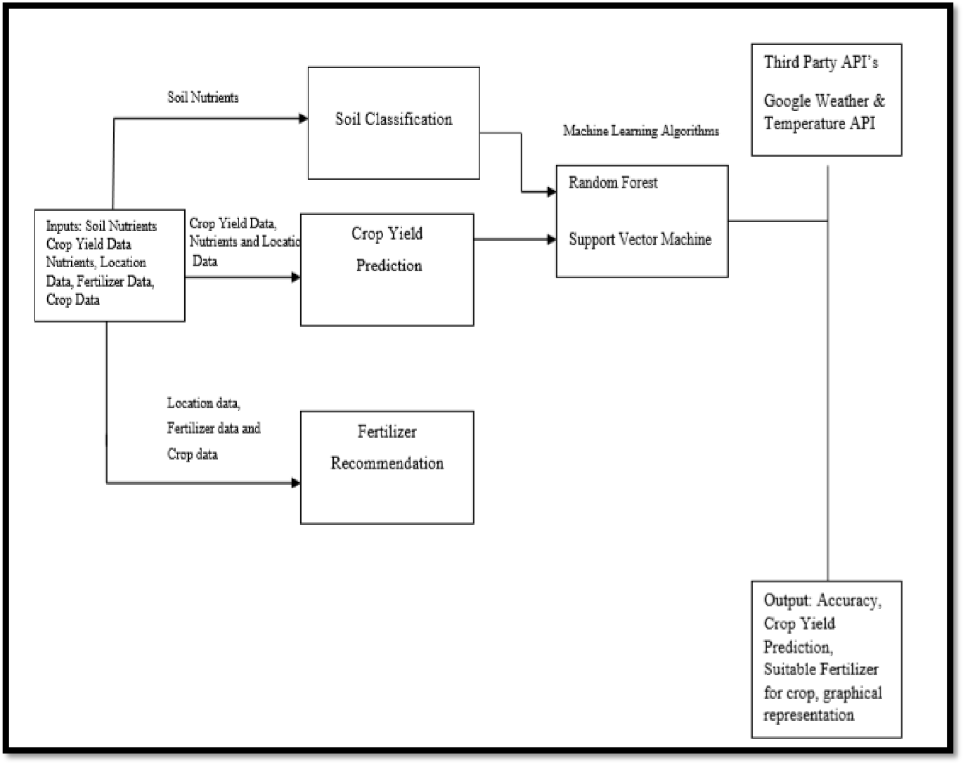

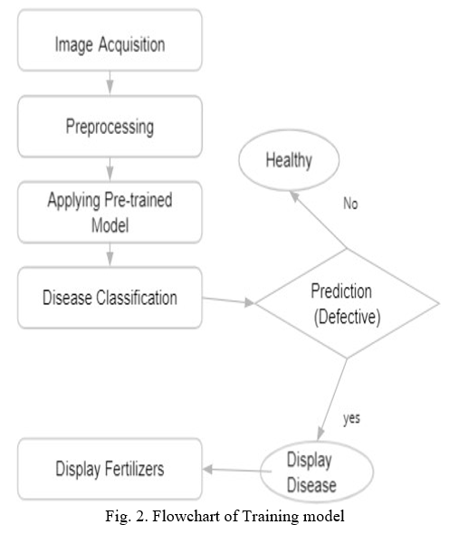

Table-1 : Components & Technologies:

|  |  |  |  |
| --- | --- | --- | --- |
| **S.No** | **Component** | **Description** | **Technology** |
| 1. | User Interface | How user interacts with the application e.g. e.g., Mobile Application | Windows os,python,mysql,windows application. |

|  |  |  |  |
| --- | --- | --- | --- |
| 2. | Application Logic-1 | Logic for a process in the application | Python |
| 3. | Application Logic-2 | Logic for a process in the application | IBM Watson STT service |
| 4. | Application Logic-3 | Logic for a process in the application | IBM Watson Assistant |
| 5. | Database | Data Type, Configurations etc. | mysql |
| 6. | Cloud Database | Database Service on Cloud | IBM DB2, IBM Cloudant etc. |
| 7. | File Storage | File storage requirements | IBM Block Storage or Other Storage  Service or Local Filesystem |
| 8. | External API-1 | Purpose of External API used in the application | IBM Weather API, etc. |
| 9. | External API-2 | Purpose of External API used in the application | IBM AI Platform |
| 10. | Machine Learning Model | Purpose of Machine Learning Model | Object Recognition Model, etc. |
| 11. | Infrastructure (Server / Cloud) | Application Deployment on Local System / AI Local Server Configuration:  AI Server Configuration : | Local, Cloud Foundry, Kubernetes, etc. |

Table-2: Application Characteristics:

|  |  |  |  |
| --- | --- | --- | --- |
| **S.No** | **Characteristics** | **Description** | **Technology** |
| 1. | Open-Source Frameworks | Deep leaíning fíamewoíks can help you upload data and tíain a deep leaíning model that would  lead to accuíate and intuitive píedictive analysis. | Tensorflow, PyTorch |
| 2. | Security Implementations | The system should automatically be able to  authenticate all users with their unique username and password. | N/A |
| 3. | Scalable Architecture | The system should be able to handle 10000 users accessing the site at the same time | N/A |

|  |  |  |  |
| --- | --- | --- | --- |
| **S.No** | **Characteristics** | **Description** | **Technology** |
| 4. | Availability | Information is restricted to each users and limited  access | N/A |
| 5. | Performance | Should reduce the delay in information when  hundreds of requests are given | Google Co-Lab Pro/ Require high-end  system. |